# FD : post-transaction-app

Author Name: Developer Guide

Date Of Assignment: 10-09-2021

Date Of Submission: 10-09-2021

Document detail

|  |  |  |  |  |
| --- | --- | --- | --- | --- |
| Name | Description | Version | Comment | Date |
| Developer Guide | Initial Draft | 1.0 |  | 10-09-2021 |
| Kumar | Review Comment | 1.1 |  |  |
|  |  | 1.2 |  |  |

Document Future Scope

|  |
| --- |
|  |
|  |
|  |
|  |
|  |

# FUNCTIONAL REQUIREMENT

# Business Scenario

This Api will store customer transaction details in SFDC system.

# Flow diagram

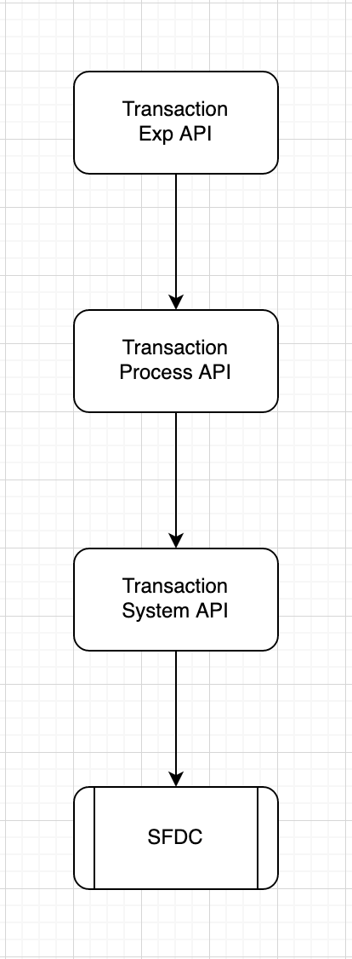

# Sequence Diagram Web Application

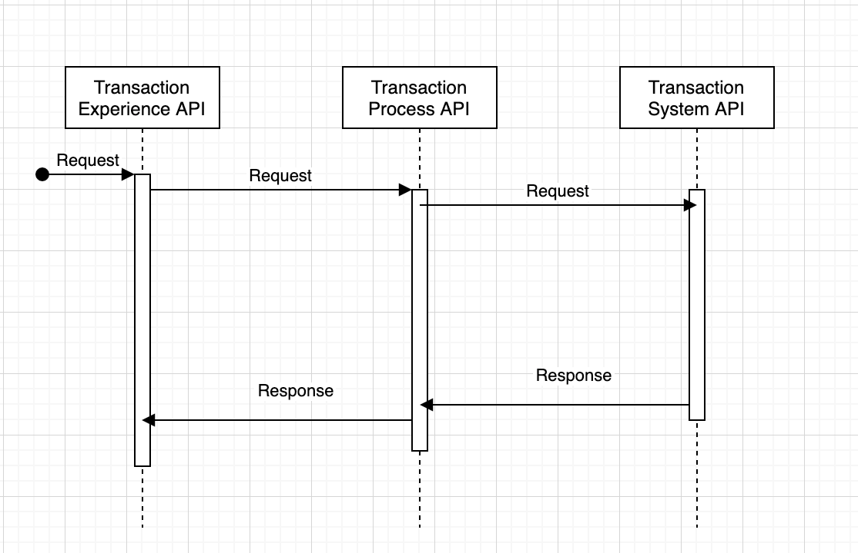

# API Details

1. **System API**

|  |  |
| --- | --- |
| **Version** | 1.0.0 |
| **Resource** | /members/transactions |
| **Method** | POST |
| **Objective** | This API will create transaction details in customer CRM system |

# INPUT

## Header

|  |  |  |  |
| --- | --- | --- | --- |
| **Field Name** | **Field Rule** | **Mandatory** | **Type** |
| X-lyt-transactionId | Use for logging and tracking purposes. Example: hdsfhjdh-jxbv859-sjdf7643-3746bbd  MinLength = 36  MaxLength = 36 | Y | String |
| X-lyt-channel | Enum: Mobile/WebApp | Y | String |
| X-lyt-OriginLanguage | Original Language (en,zh) | Y | String |
| X-lyt-OriginMarket | Original business market (IND/US/CND) | Y | String |
| ClientId | Ex : jhdfjhvdfj38748763we87 | Y | String |
| ClientSecret | Ex: kjfdksh8w47ryt487te4t | Y | String |

## Request Body

MIME-Type = application/json

|  |  |  |  |  |
| --- | --- | --- | --- | --- |
| **Field Name** | **Field Rule** | **Description** | **Mandatory** | **Type** |
| memberId | 1 | Mem34576345 | Y | String |
| transactionId | 1 | TXN72y483 | Y | String |
| amount | 1 | 10000 | Y | Integer |
| memberTier | 1 | enum : T1/T2/T3/T4 | Y | String |
| transactionDate | 1 | 04-04-2021 | Y | String |

## OUTPUT

### 201:

Body: MIME-Type= application/json

Output message for Forgot Username/Password

|  |  |  |  |  |
| --- | --- | --- | --- | --- |
| **Field Name** | **Field Rule** | **Description** | **Mandatory** | **Type** |
| msg | 1 |  | Y | String |
| code | 1 |  | Y | Integer |
| success | 1 |  | Y | boolean |
| eventId | 1 | Request header transactionId | Y | string |
| data | 1 |  | Y | object |
| memberId | 2 |  | Y | String |
| status | 2 | Success/Failed | Y | String |

example:

{

"msg" : "successful operation",

"code" : 201,

"success" :true,

"eventId" : "dbfhjsdbhfbdo8ryt876t75ty",

"data" **:**

{

"memberId" :"Mdsah8734873",

"status" : "Success"

}

}

SFDC :

Object : Transaction

|  |  |  |
| --- | --- | --- |
| Column | DataType | Description |
| memberId | String | Request Payload memberId |
| transactionId | String | Request Payload transactionId |
| amount | Integer | Request Payload amount |
| memberTier | String | Request Payload memberTier |
| transactionDate | String | Request Payload transactionDate |

1. **Process API**

|  |  |
| --- | --- |
| **Version** | 1.0.0 |
| **Resource** | /members/transaction |
| **Method** | POST |
| **Objective** | This API will retrieve login credentials |

# INPUT

## Header

|  |  |  |  |
| --- | --- | --- | --- |
| **Field Name** | **Field Rule** | **Mandatory** | **Type** |
| x-cms-transactionId | Use for logging and tracking purposes. Example: hdsfhjdh-jxbv859-sjdf7643-3746bbd  MinLength = 36  MaxLength = 36 | Y | String |
| x-cms-channel | Mobile/WebApp | Y | String |
| X-Cms-OriginLanguage | Original Language | Y | String |
| X-Cms-OriginMarket | Original business market | Y | String |
| ClientId | Ex : jhdfjhvdfj38748763we87 | Y | String |
| ClientSecret | Ex: kjfdksh8w47ryt487te4t | Y | String |

## Request Body

MIME-Type = application/json

|  |  |  |  |  |
| --- | --- | --- | --- | --- |
| **Field Name** | **Field Rule** | **Description** | **Mandatory** | **Type** |
| memberId | 1 | Mem34576345 | Y | String |
| transactionId | 1 | TXN72y483 | Y | String |
| amount | 1 | 10000 | Y | Integer |
| memberTier | 1 | T1/T2/T3/T4 | Y | enum |
| transactionDate | 1 | 04-04-2021 | Y | date |

## OUTPUT

### 200:

Body: MIME-Type= application/json

Output message for Forgot Username/Password

|  |  |  |  |  |
| --- | --- | --- | --- | --- |
| **Field Name** | **Field Rule** | **Description** | **Mandatory** | **Type** |
| msg | 1 |  | Y | String |
| code | 1 |  | Y | Integer |
| success | 1 |  | Y | string |
| eventId | 1 | Request header transactionId | Y | string |
| data | 1 |  | Y | object |
| memberId | 2 |  | Y | String |
| status | 2 | Success/Failed | Y | String |

example:

{

"msg" : "successful operation",

"code" : 200,

"success" :true,

"eventId" : "dbfhjsdbhfbdo8ryt876t75ty"

"data" **:**

{

"memberId" :"Mdsah8734873",

"status" : "Success"

}

}

1. **Experience API**

|  |  |
| --- | --- |
| **Version** | 1.0.0 |
| **Resource** | /members/transaction |
| **Method** | POST |
| **Objective** | This API will retrieve login credentials |

# INPUT

## Header

|  |  |  |  |
| --- | --- | --- | --- |
| **Field Name** | **Field Rule** | **Mandatory** | **Type** |
| x-cms-transactionId | Use for logging and tracking purposes. Example: hdsfhjdh-jxbv859-sjdf7643-3746bbd  MinLength = 36  MaxLength = 36 | Y | String |
| x-cms-channel | Mobile/WebApp | Y | String |
| X-Cms-OriginLanguage | Original Language | Y | String |
| X-Cms-OriginMarket | Original business market | Y | String |
| Authorization | JWT token | Y | String |
| ClientId | Ex : jhdfjhvdfj38748763we87 | Y | String |
| ClientSecret | Ex: kjfdksh8w47ryt487te4t | Y | String |

## Request Body

MIME-Type = application/json

|  |  |  |  |  |
| --- | --- | --- | --- | --- |
| **Field Name** | **Field Rule** | **Description** | **Mandatory** | **Type** |
| memberId | 1 | Mem34576345 | Y | String |
| transactionId | 1 | TXN72y483 | Y | String |
| amount | 1 | 10000 | Y | Integer |
| memberTier | 1 | T1/T2/T3/T4 | Y | enum |
| transactionDate | 1 | 04-04-2021 | Y | date |

## OUTPUT

### 200:

Body: MIME-Type= application/json

Output message for Forgot Username/Password

|  |  |  |  |  |
| --- | --- | --- | --- | --- |
| **Field Name** | **Field Rule** | **Description** | **Mandatory** | **Type** |
| msg | 1 |  | Y | String |
| code | 1 |  | Y | Integer |
| success | 1 |  | Y | string |
| eventId | 1 | Request header transactionId | Y | string |
| data | 1 |  | Y | object |
| memberId | 2 |  | Y | String |
| status | 2 | Success/Failed | Y | String |

example:

{

"msg" : "successful operation",

"code" : 200,

"success" :true,

"eventId" : "dbfhjsdbhfbdo8ryt876t75ty"

"data" **:**

{

"memberId" :"Mdsah8734873",

"status" : "Success"

}

}

### 400:

Body: MIME-Type= application/json

Output message for MemberLogin

|  |  |  |  |
| --- | --- | --- | --- |
| **Field Name** | **Field Rule** | **Mandatory** | **Type** |
| msg | 1 | Y | String |
| code | 1 | Y | Integer |
| success | 1 | Y | Boolean |
| eventId | 1 | Y | string |
| error | 1 | Y | Object |
| type | 2 | Y | String |
| title | 2 | Y | String |
| details | 2 | Y | String |

example:

{

"msg": "failed operation",

"code": 400,

"success": false,

"eventId": "dbfhjsdbhfbdo8ryt876t75ty"

"error":

{

"type": "BAD_REQUEST",

"title": "Invalid Request",

"details": "The input contains invalid data, amount should be integer"

}

}

### 401:

Body: MIME-Type= application/json

Output message for MemberLogin

|  |  |  |  |
| --- | --- | --- | --- |
| **Field Name** | **Field Rule** | **Mandatory** | **Type** |
| msg | 1 | Y | String |
| code | 1 | Y | Integer |
| success | 1 | Y | Boolean |
| eventId | 1 | Y | string |
| error | 1 | Y | Object |
| type | 2 | Y | String |
| title | 2 | Y | String |
| details | 2 | Y | String |

example:

{

msg: "failed operation",

code: 401,

success: false,

eventId: "dbfhjsdbhfbdo8ryt876t75ty"

error:

{

type: "UNAUTHORIZED",

title: "Unauthorized",

details: "This endpoint requires all requests to be authenticated"

}

}

### 404:

Body: MIME-Type= application/json

Output message for MemberLogin

|  |  |  |  |
| --- | --- | --- | --- |
| **Field Name** | **Field Rule** | **Mandatory** | **Type** |
| msg | 1 | Y | String |
| code | 1 | Y | Integer |
| success | 1 | Y | Boolean |
| eventId | 1 | Y | string |
| error | 1 | Y | Object |
| type | 2 | Y | String |
| title | 2 | Y | String |
| details | 2 | Y | String |

example:

{

msg: "failed operation",

code: 404,

success: false,

eventId: "dbfhjsdbhfbdo8ryt876t75ty"

error:

{

type: "NOT_FOUND",

title: "Resource not found",

details: "The URI requested is invalid or the resource requested does not exists"

}

}

### 500:

Body: MIME-Type= application/json

Output message for MemberLogin

|  |  |  |  |
| --- | --- | --- | --- |
| **Field Name** | **Field Rule** | **Mandatory** | **Type** |
| msg | 1 | Y | String |
| code | 1 | Y | Integer |
| success | 1 | Y | Boolean |
| eventId | 1 | Y | string |
| error | 1 | Y | Object |
| type | 2 | Y | String |
| title | 2 | Y | String |
| details | 2 | Y | String |

example:

{

msg: "failed operation",

code: 500,

success: false,

eventId: "dbfhjsdbhfbdo8ryt876t75ty"

error:

{

type: "SERVER_ERROR",

title: "Internal server error",

details: "The server encountered an unexpected condition which prevented it from fulfilling the request"

}

}